
Table of Contents
The Derailleur
TRAILBLAZERS Tandem Cycling Club
www.torontotrailblazers.org (416) 760-2770
Vol. 3, Issue 1 – Spring 2011

- Message from the President
- Stoker’s Profile
- Captain’s Profile
- Off-Tandem Season Fitness
- World Bicycle Relief
- Siew Lan Low Trust Fund
- 2011 Bike Ride Schedule

From the President
mARTIN cOURCELLES

It's been an honour to be the TRAILBLAZERS president for this, the 23rd year of the club's existence. I still find it amazing that the club started with only a few bikes and we now have almost 20 bikes and 4 sheds across the GTA.
However, the club would not be in existence without your participation. Whether you're a captain piloting one of our bikes, a member busily peddling on the back of our tandems or one of our many volunteers, we all endeavour to reach the same goal. To stay fit, meet new people and simply have fun. I was going to recount all of our successes this year, but I decided to sum it up in one all encompassing thought. The TRAILBLAZERS Tandem Cycling Club is our success. Be proud of it.
Remember to shine up your biking gear in April as that's when the new TRAILBLAZERS year will start. And perhaps, give a thought at running for one of the positions on the TRAILBLAZERS board. It's an experience you'll never forget and you'll be contributing your talents and energy to a worthy cause. If board duties aren’t your thing, volunteer your time for the various projects we’ll have over the biking months.
Although I’m stepping down from presidency and the executive, you will still see me participating as an avid member. I will also be volunteering at various conferences and shows.
Make a difference. Get involved with your club.
Only you can engender change.

Stoker’s Profile
ROBERT HAMPSON

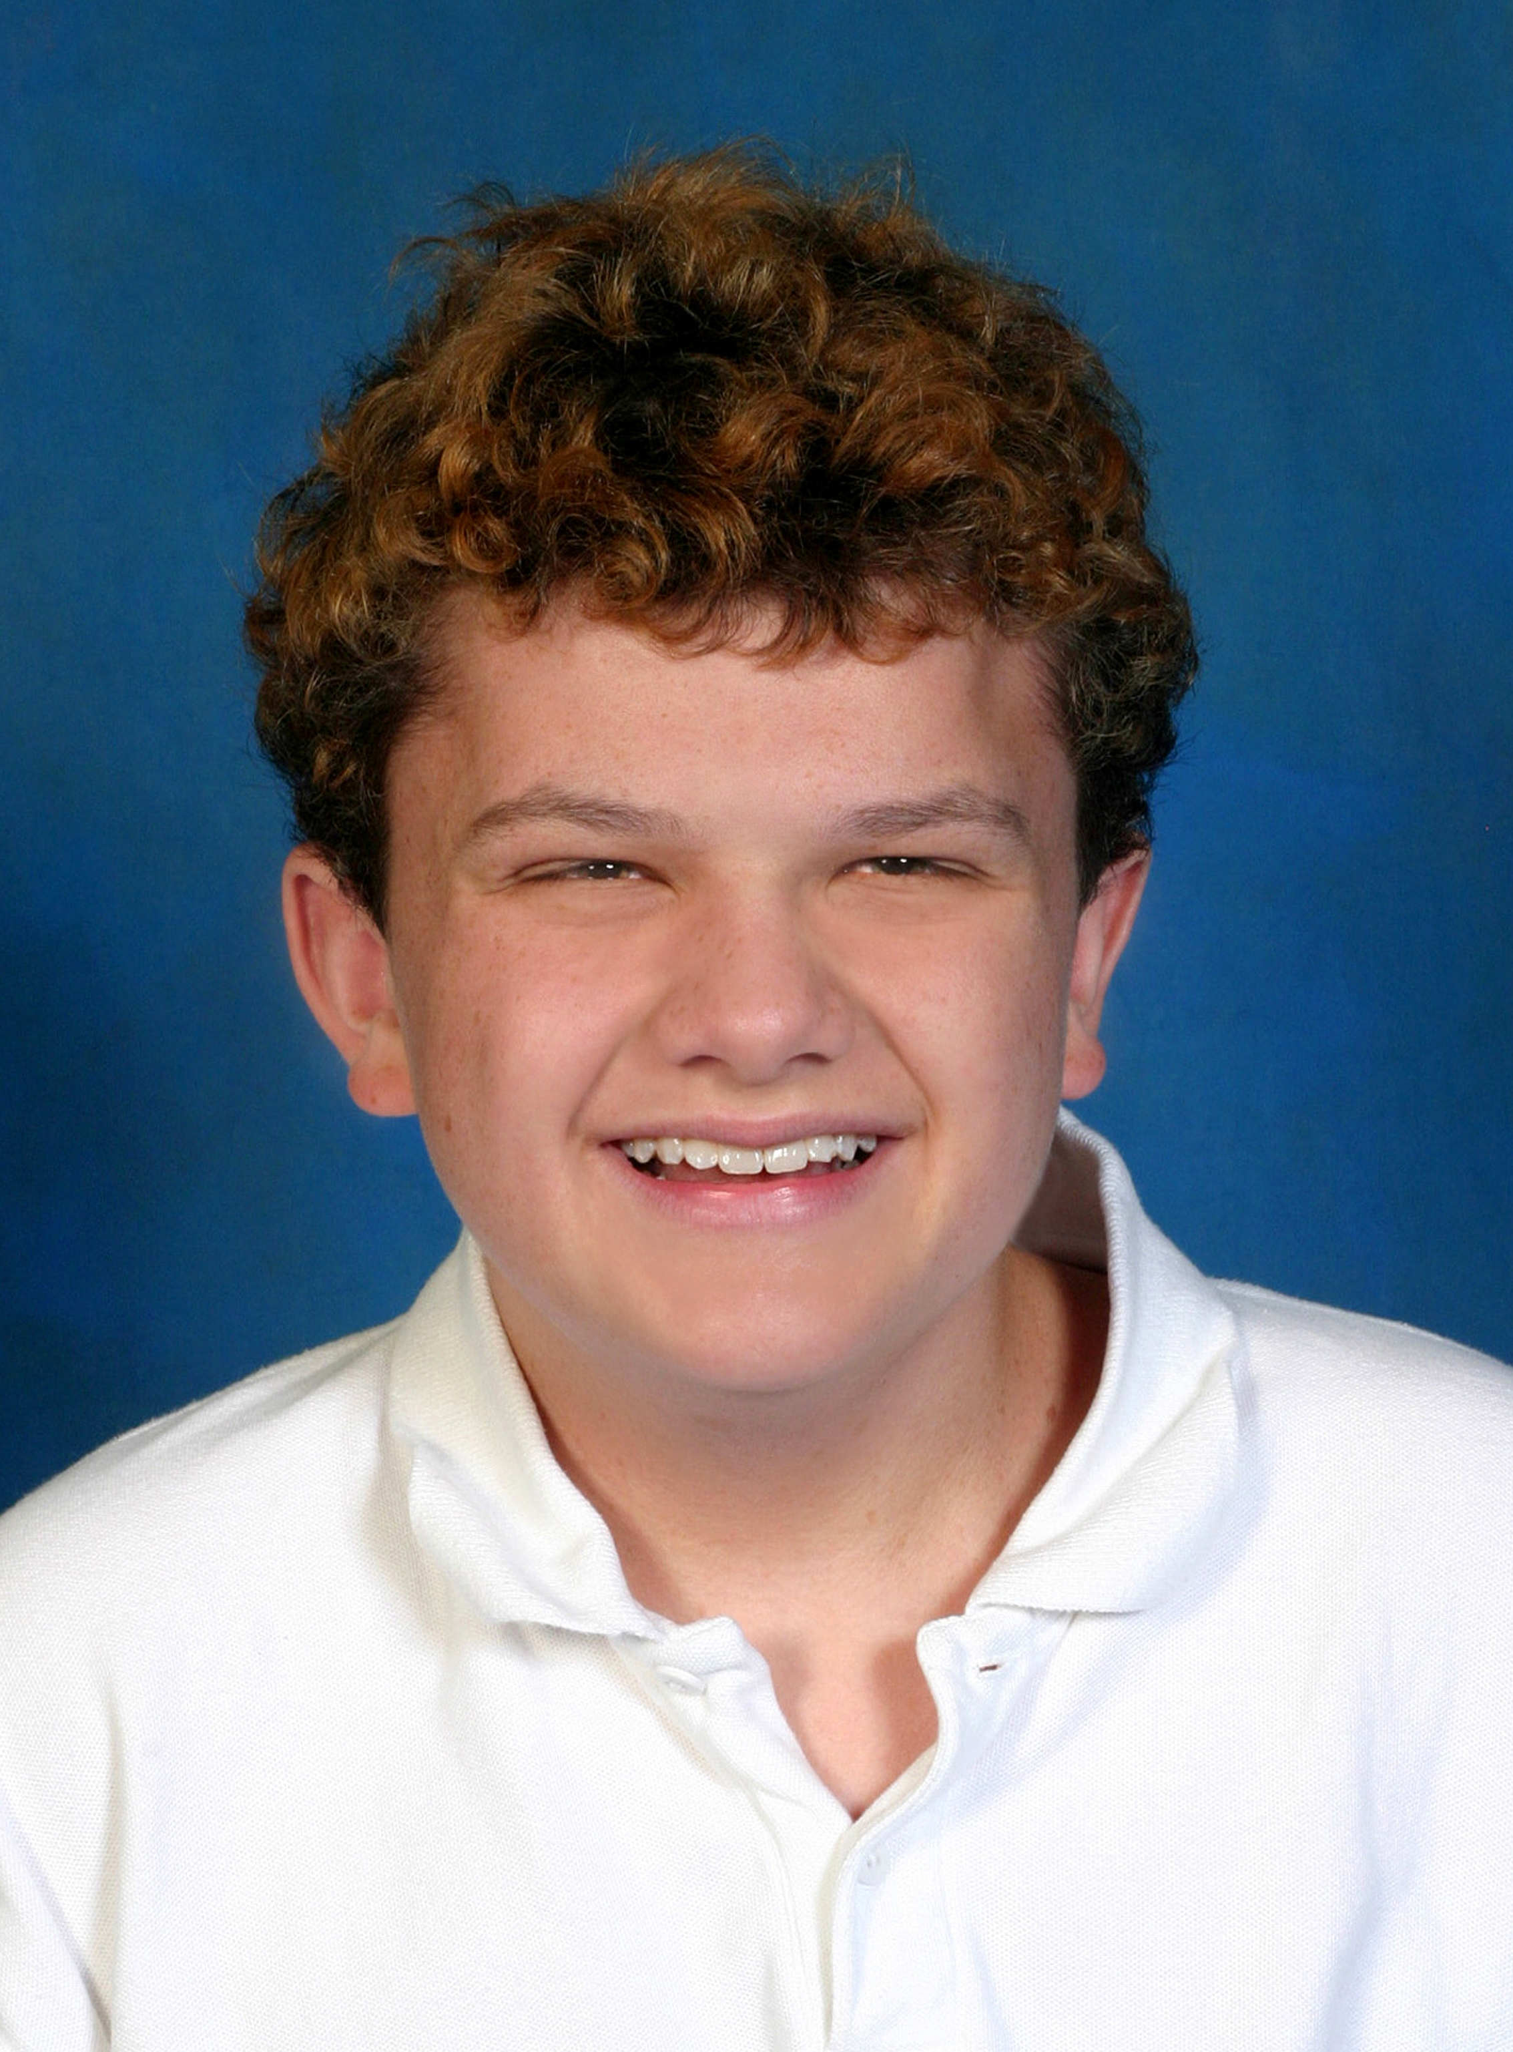
Robert is 18 and studies at the W. Ross MacDonald School in Brantford. He has been tandem bike riding since he was 8 and would often go riding with his Dad. Then he heard about the TRAILBLAZERS through the Toronto Ski Hawks.

“I really love it. It gives me a chance to get out and get some exercise. It’s nice because is gives me a place to meet new friends and be with other people who really love it.”

“The Toronto Island Ride is my favorite ride. It has lots of biking paths, nice trails and no cars. There are always things to stop and look at. It is a good place to stop and socialize, with lots of nice areas.”

Robert has been riding with the TRAILBLAZERS for two years and looks forward to riding this year. He would like to encourage more young people to join and get involved.

Captain’s Profile
BarBARA TRUAX

Every year I volunteer for a different charity. Last winter I was perusing the volunteer section of craigslist.ca and was quickly becoming frustrated with what I saw.

Volunteer abroad…. not me I hate traveling.
Coach teenagers…. No I have two teens.
Volunteer at a hospital…. No I work in one.
Volunteer at a farm…No I’m allergic.
Volunteer sperm donor…No I am a woman.

Then I saw it…Tandem Cycling Club Open House …that sounds cool. I can bicycle. I am not sure about the tandem part but I can bicycle.
I quickly scanned the four paragraphs and checked the website which was listed.
Information meeting March 31, 6-8 p.m. I am available to go and find out about it.
At the CNIB …Wow only 10 minutes from my house…..so far I can do this…
I would like to thank everyone involved with TRAILBLAZERS. I had a wonderful summer 2010 going on 22 recreational rides with two stokers Vivian and Maria. I also participated in the Toronto Island group ride and the 50 K fundraiser.
Recently I opened craigslist.ca to check the ads for my volunteer opportunity for 2011. The first ad I saw: Volunteer to clean my house… No, not a chance.
TRAILBLAZERS, you might be stuck with me again this year.

Barbara

Off-Tandem Season Fitness
Elizabeth zys
It is time to reflect upon our achievements and make new goals for the 2011 season.
Whether trying to work on overall or specific cycling fitness, here are some pillars we can all set our programs around:
- Core Strength. Working on the connective tissues of the abdominals and back. Improves posture and balance and develops ability to cycle from the core and not the knees and ankles!
- Stretching. Improving flexibility will decrease the risk of injuries.
- Aerobic conditioning and breathing exercises. Feel more relaxed during taxing physical output.
- Hydration. We spend more time in dry, indoor conditions. And water generates body heat.
Find a program you like! A workout friend can help with motivation and commitment. There is a wealth of resources available to us. Adaptations such as a tandem bike make exercise more accessible and help us overcome our first time fears. Individualize your program using household products, joining a structured class for blind/visually impaired, or participate in an integrated program in the community.
Whether the activity is specific to cycling or not, we should all aim to participate in targeting one of the pillars listed above. Here are some resources and ideas to follow up upon:
- Home workouts. Improvise with resistance bands, chairs, and self made weights. Use equipment in an apartment gym. Stair climbing and walking, with or without poles, are great choices. Many malls offer indoor walking groups. Isometrics and movements such as shoulder rolls can improve flexibility.
- Yoga classes improve core strength, balance, breathing, and flexibility. The ‘Plank Pose’ is particularly good at improving core strength.
BALANCE: Contact Tricia Morley at t.morley@balancefba.org. Tricia’s number is (416) 236-1796, Ext. 29.
$40 for 8 classes or $6 per class
CNIB: Contact Sue Taylor (Susan) at suetaylor@avaya.com. Classes are $5 each. This is for blind participants only.
- There are many convenient community centres offering city run programs. They strive to provide services in the spirit of co-operation and recognize that adaptations may be necessary to participate. Welcoming everyone to participate regardless of ability to pay – ask about the “Welcome Policy”
- Contact one of the Adapted & Integrated Services Staff in your area:
NORTH YORK: Matt Hilts: 416-395-6183 TTY: 416-395-6115
TORONTO & EAST YORK: Serena De Souza: 416-397-4923 TTY: 416-392-4773
SCARBOROUGH: Elaine Devine: 416-396-7760 TTY: 416-396-4116 ETOBICOKE YORK: Lindsay Mogford: 416-394-8746 TTY: 416-394-8534
- Spin Classes. Offered by many gyms and specific spin gyms. Range in price from $15-$25 per classes, with packages offered at discounts. A day pass or individual class is a good way to see if you like them. Spinning can be strenuous, but each individual can tailor a class to their own ability by slowing down the pace, staying seated, or reducing the tension. it is wise to meet with the instructor to discuss the nature of the classes structure and to familiarize yourself with the adjustment points on a spin bike. The YMCA is a good starting point.
Throw a fitness party and have fun! You will feel more energized, sleep better, have more confidence, and be ready for the tandem this year!

World Bicycle Relief
Jonathan Nix
Knowing the generous nature of TRAILBLAZERS members, I thought you would be interested in this great initiative: World Bicycle Relief. Formed in 2005 by SRAM, a bike parts manufacturer, and Trek, WBR aims to help empower people with bicycles.
By providing children in rural Zambia with bicycles, we can help reduce their commute to school from up to four hours to under one hour. After the tsunami in Indonesia, the power of bicycles has helped those affected reclaim their livelihood by allowing them to effectively commute to work. In Kenya, a bicycle can multiply a healthcare volunteer’s effectiveness, enabling them to see up to 20 patients each week. Most importantly, WBR trains local men and women so that their fleet of donated bicycles can be well maintained and long-lasting.
Bicycles are so simple and often something I’m sure we all take for granted. While we use our bicycles to exercise and have fun, for many people around the world, bicycles can change lives. If any of you are interested, check out their website http://www.worldbicyclerelief.org. Let’s let the magnanimous spirit of TRAILBLAZERS help stoke the passion of dedicated people like those at World Bicycle Relief.

Siew Lan Low Fund
Just a reminder, the Siew Lan Low Fund is available to members in need. This fund can be accessed once per season to a maximum of $40 to offset the cost of an outing. Contact the president for more information at (416) 760-2770. Applications are kept anonymous.

HAPPY VOLUNTEER APPRECIATION WEEK

We would like to thank our Captains for volunteering time in the past year.
TRAILBLAZERS exists due to your generosity and dedication and we hope to see you in the new season.
2011 Ride schedule
For more info & updates, visit:
www.torontotrailblazers.org/activities.html
- Sun. April 17 –Breakfast Ride (CNIB)*
- Sun. April 17 –Breakfast Ride (S)
- Sat. April 30 – Taylor Creek (CNIB)
Note: This will be our promotional video shoot ride.
- Sat. May 14 – Beaches Ride (S)
- Sat. May 14 – Port Credit (S)
- Sun. May 29 – Leslie Spit (CNIB)
- Sun. May 29 – Centre Island (W)
- Sat. June 12 – Blaze-A-Thon (CNIB,S)
- Sat June 25 – Cycle for Sight
- Fri. July 1- Canada Day Ride TBA
- Sun. July 17 – Lake Simcoe (Keswick)
- Jul.30 – Aug.1– TBN Cyclone Ride
- Sun. Aug 7 – TB Picnic
- Sat. Aug 20 – Barrie Ride (Barrie)
- Sat. Sept. 10 – Niagara on the Lake
- Sun. Sept. 25 – Scarborough Bluffs (CNIB)
*(Shed) CNIB, W-west, S-south

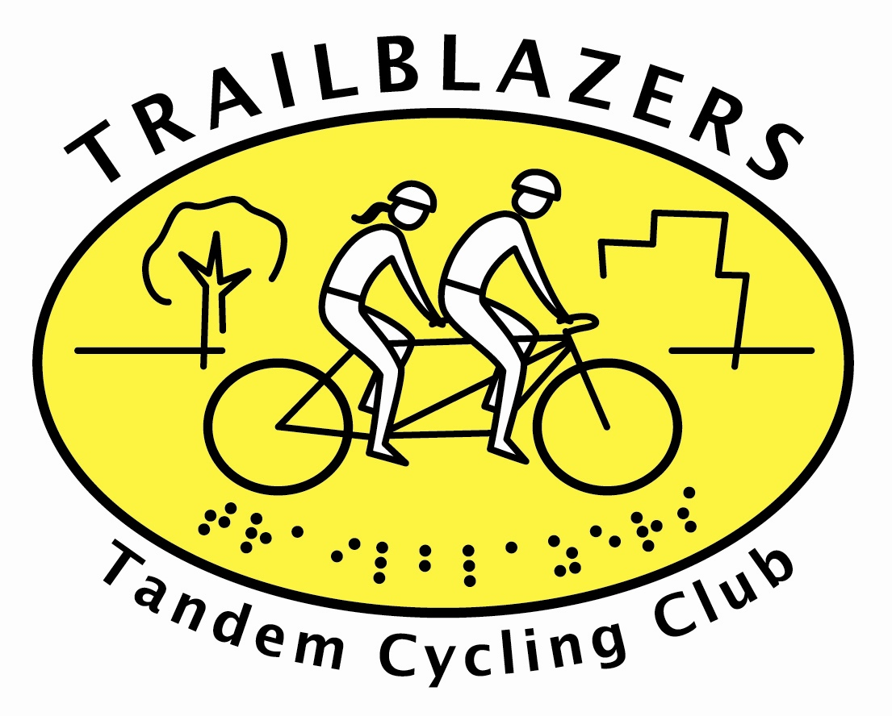
Donation Form

Yes! I would like to support the TRAILBLAZERS Tandem Cycling Club Funds are used to support new tandem purchases, bicycle maintenance and operations and social events.

Enclosed is my donation of:
$25.00  $50.00 
$100.00  $200.00  *Other _____________

❒ Cheque enclosed (payable to TRAILBLAZERS Tandem Cycling Club)

❒ Credit Card - Donate securely online using Canada Helps at www.torontotrailblazers.org/donate

*Official Tax Receipts are available upon request for donations of $10 or more, issued automatically for donations of $25 or more.
Registered Charity #86786 4753 RR 0001

Name ________________________________
Street ________________________________
City & province__________________________
Postal code_____________________________
Phone ________________________________
Email____________________________________
Mail to:
TRAILBLAZERS Tandem Cycling Club
188 Highfield Rd
Toronto ON M4L 2V21

Thank you for supporting the TRAILBLAZERS!

